Contents
- Data, Processed Data and Information
- Data Source, Data Stores: File, Database
- Types of Data: Structured, Semi-structured and Un-structured
- DBMS (Database Management System)
- OTP vs OLAP
- Row Oriented and Column Oriented Database
- MySQL Overview
- MySQL Client Server Architecture
- Database vs Schema
- Performing Basic Database Operation
- Importance of SQL for Data Engineer
Data
- Data is raw fact or values.
- It is not processed.
- It may contain missing values, duplicates, or incorrect data.
- We cannot perform analysis on raw data.
Processed Data
- Processed data is data that has been cleaned.
- Processing includes:
  - Removing missing values
  - Removing duplicates
  - Correcting inconsistent values
- It will not have missing values, duplicates, or incorrect data.
- We can perform analysis on processed data.
Information
- Information is the result of analyzing the processed data.
- Example:
  - Find the student who has the highest marks.
  - Find the average marks of the students.
  - Find the average age of the students.
Data Source
- A data source is a place where data is generated.
- Example:
  - Website
  - Mobile Application
  - Etc.
Data Store
- A data store is a place where data is stored.
- Example:
  - File
  - Database
File Vs. Database
 | File | Database
Handling Large Data | No | Yes
Searching Data | Difficult | Easy
Relationships | Cannot link data between files | Can link tables
Security | Weak | Strong

Types of Data
- Structured data
- Semi-Structured data
- Unstructured data
Structured Data
- Structured data is organized data.
- It follows a fixed format (rows and columns).
- Example:
  - Customer information:
Name | Age | Address | Phone
Raj | 30 | BBSR | 5551112221

Semi- Structured Data
- Semi-Structured data is partially organized data.
- It uses key-value pairs.
- Example
  - JSON data
{
"name": "RaJ ",
"age": 30,
"address": "BBSR"
}
Unstructured data
- Unstructured data is unorganized data.
- There is no predefined structure or format.
- Example;
  - Image
  - Audio
  - Video
  - Etc.
DBMS
- DBMS stands for Database Management System.
- It's a software application that helps you create, manage, and access databases.
- Types of DBMS
  - Relational DBMS
  - NoSQL DBMS
Relational DBMS
- Relational database store data in tables.
- Fixed schema.
- Examples:
  - MySQL
  - PostgreSQL
  - Oracle
  - SQL Server
  - Etc.
NoSQL DBMS
- NoSQL (Not only SQL) database uses key-value, graph and document data structure to store data.
- Flexible schema.
- Example:
  - Redis
  - Neo4J
  - Mongo DB
  - Etc.
OLTP vs. OLAP
- OLTP (Online Transaction Processing)
  - It handles day-to-day transactional activities.
  - Example:
    - databases
- OLAP (Online Analytical Processing)
  - It handles historical data.
  - Supports complex analysis.
  - Example:
    - Data Warehouse
Row Oriented and Column Oriented Database
- Row-oriented database
  - All the data for a single row is stored together on disk.
  - It is suitable for online transactional processing.
- Column-oriented database
  - All the data for a single column is stored together on disk.
  - It is suitable for complex analysis for historical data.
MySQL Overview
- MySQL is a row-oriented, relational database management system designed for online transaction processing (OLTP).
- MySQL comes in 2 versions:
  - Community (Free)
  - Enterprise (Paid)
MySQL Client Server Architecture
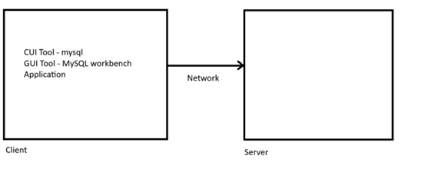
Different ways to Connect with MySQL
- CUI (Character User Interface) Tool
- GUI (Graphical User Interface) Tool
Command line Client
- It provides CUI tool used to connect with MySQL server.
- Connection Parameter
  - Database Host Name/ IP
  - Database Port Number
  - Database Username
  - Database Password
- Syntax:
  - mysql –h hostname –P portno –u <username> –p <password>
MySQL Workbench
- It is a GUI tool used to connect with MySQL server.
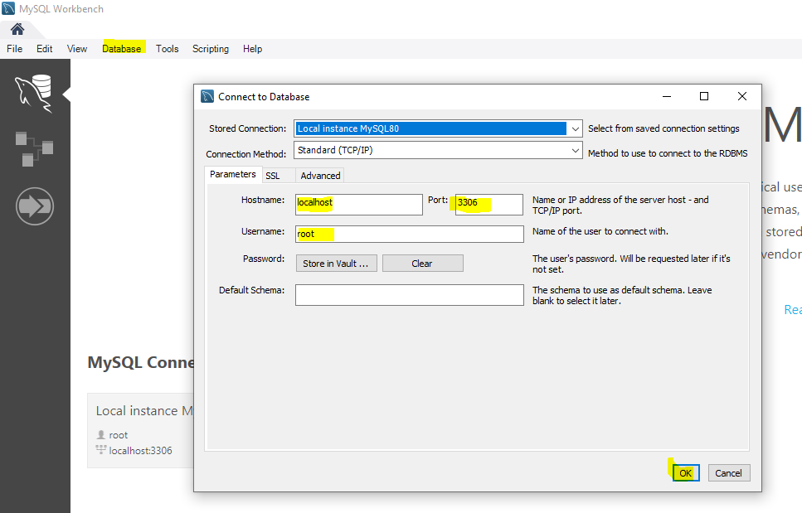

Database vs. Schema
- In MySQL, a database and a schema are the same thing (Database Tables).
- In PostgreSQL, a database is a higher-level container, and inside one database, we can have multiple schemas (Database Schema Tables).
Basic Operation with Database
- Showing Databases
  - To lists all available databases
show databases;
- Creating Database
  - Creates a database with the specified name
create database <database-name>;
create database if not exists <database-name>;
- Deleting Database
  - Deletes an entire database
drop database <database-name>;
drop database if exists <database-name>;
- Using Database
  - Sets the specified database as the current working database for subsequent SQL commands
use <database-name>;
- Showing Current Working Database
  - Returns the name of the database that is currently selected
SELECT database();
Importance of SQL for Data Engineer
- SQL is used at every stage of the data pipeline: extracting, cleaning, transforming, storing, and analyzing data.

